DEEP LEARNING EXPERIMENT OUTPUTS

**EXP-1:** Deep Learning Basic with Keras and Tensor flow

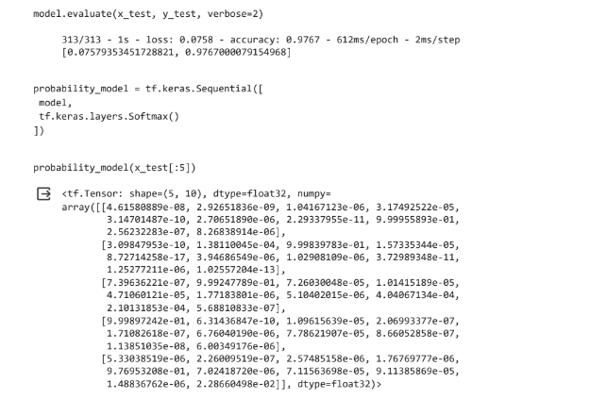

**EXP-2:** Multilayer Perceptron algorithm to Simulate XOR gate

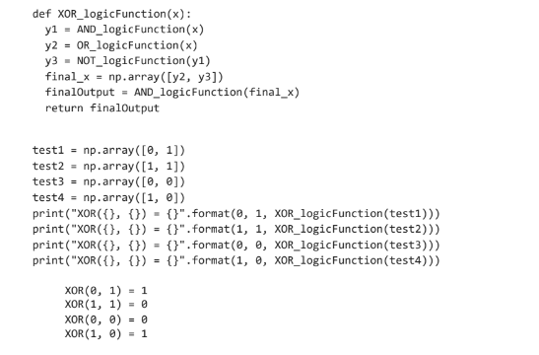

EXP 2-A: Apply any of the following learning algorithms to learn the parameters of the supervised single layer feed forward neural network.

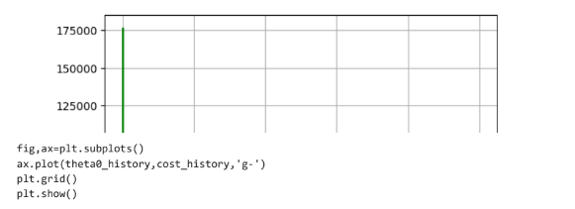

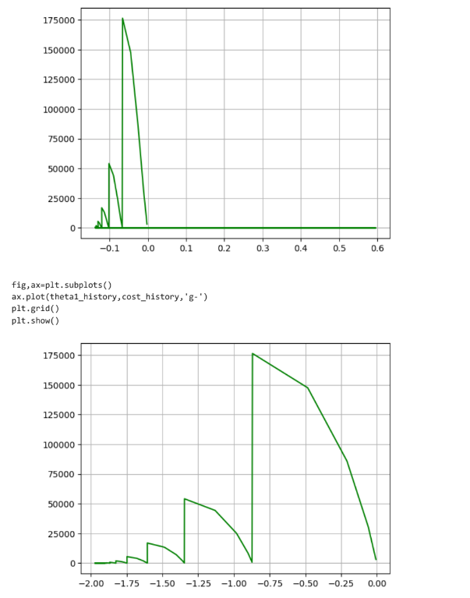

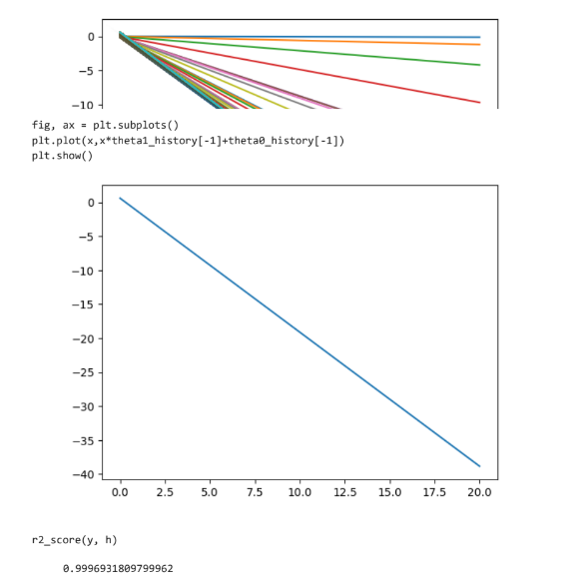

Stochastic Gradient Descent

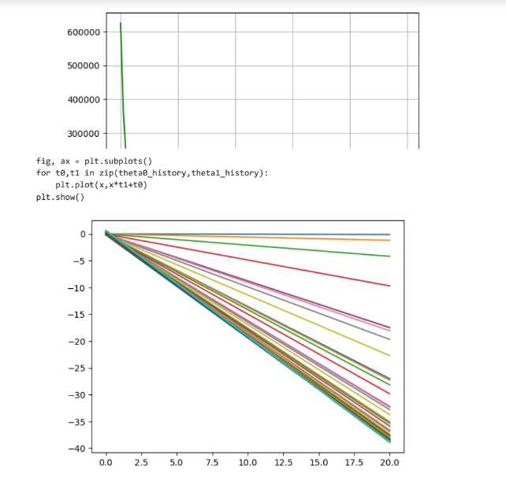

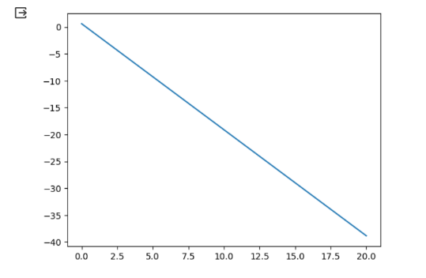

**Adam:**

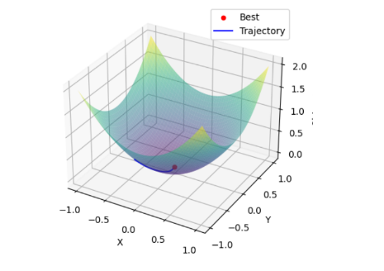

**EXP 2-B:** Implement a backpropagation algorithm to train a DNN with at least 2 hidden layers.

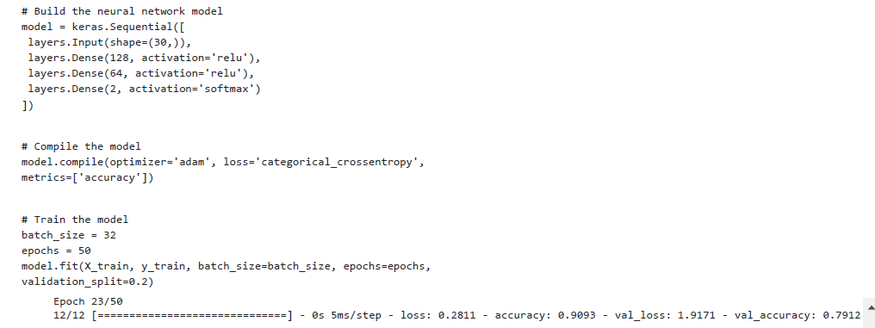

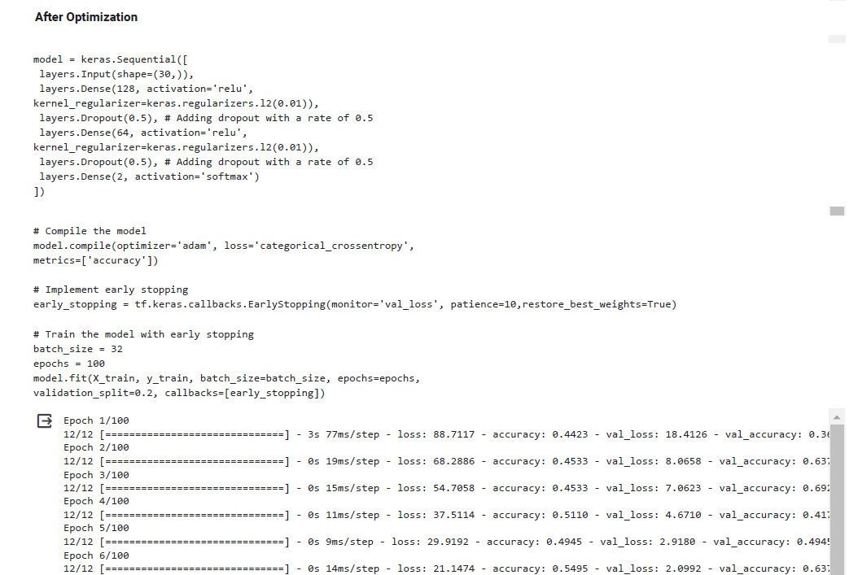

**EXP 3-A:** Autoencoder for Image Compression

